Other Foliar Diseases
Low priority
Species Affected | Foliar Disease
Pine (Pli, Py, Scots Pine) | Pine needle cast (Lophodermella concolor) DFL
Pine (Pli, Py) | Elytroderma Needle Cast (Elytroderma deformans) DFE
Spruce | Spruce Needle Blight (Rhizosphaera kalkhoffii)
Spruce | Spruce Needle Cast (Lirula macrospora) DFD
Sub-alpine fir (Bl) | Delphinella needle cast (Delfinella abietis) DFB
Bl, Ba, White fir | Fir-fireweed rust (Pucciniastrum epilobii) DFP
Red Cedar | Cedar Leaf Blight (Didymascella thujina) DFU

Description

Affecting Pine
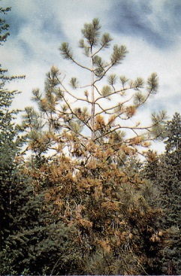
Lodgepole pine is the primary host of Lophodermella. Trees of all ages are infected, but the most damage is to young stands. Needles infected the previous year turn reddish-brown in the spring, and straw-coloured in the summer. The diseased needles on previous years' growth are shed as the summer progresses. This disease can cause severe defoliation. The years following periods of moist summer weather are favourable for infection. Growth reduction and mortality may result after repeated epidemics, particularly in young trees.

Elytroderma is a unique needle cast fungus because it can spread from needles to shoot tissue. This results in broom formation and a perennial, systemic infection, allowing the fungus to survive periods of climate unfavourable for spore release. Younger trees are affected to a greater extent than older trees.

Affecting Spruce
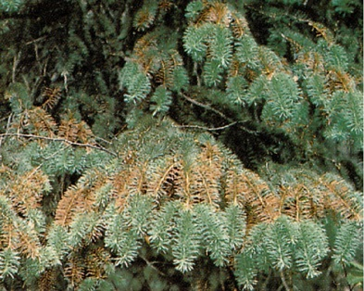
Lirula has a two-year life cycle. Infected needles become straw or brown-coloured and die. Elongated, black fruiting bodies are found on dead needles. Spruce needle cast becomes infectious to spruce every second year; therefore, tree foliage may have every second year's growth affected. Infections are more common in the lower crown. Successive years of severe infection may cause growth reduction; however, this is uncommon. Usually, there is only localized damage. Mortality seldom occurs.

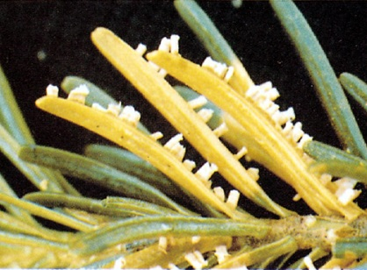
Affecting True Firs
Pucciniastrum affects Amabilis fir, white fir, and sub-alpine fir of all ages, though it is most serious in young stands. Fireweed is an alternate host. Small blisters filled with white or yellow spores develop on the lower side of current-year needles in late spring to early summer. The infected needles become chlorotic or discoloured and may be shed prematurely. Severe infection can almost completely defoliate current-year needles. Growth reduction may result. Mortality has occurred in young stands growing in recently logged areas where fireweed is abundant.

Delphinella affects sub-alpine fire. Needles and shoots are affected causing the shoots to wilt and shrivel. Dead needles and shoots remain attached for one to several years, and turn red or brown the first year, and grey or black the second year. Severe infection can halt branch and terminal growth for a year, and chronic infection can stunt tree growth.

Affecting Western Redcedar
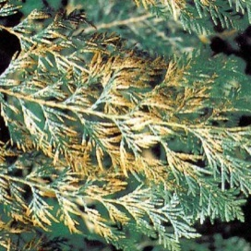
Cedar leaf blight causes infected leaves to turn reddish-brown over the summer. Dense stands growing on wetter sites are most affected. Overall losses from this disease are low, although seedlings and saplings may suffer mortality. High densities and high humidity in forest nurseries are ideal for this disease, where it can be a serious problem.

Extent
While foliar diseases other than Dothistroma needle blight are currently considered low priority forest health factors, the progression of Dothistroma in the Kispiox TSA should be seen as a warning of the potential risk that foliar diseases may pose. This risk may intensify given current predictions of climate change. Currently, the losses resulting from these defoliators are minimal.

Data

Tactics
- Incidence levels should continue to be monitored and their priority reassessed at the annual review stage.
- Species diversity should also be maintained to ameliorate the risk posed by single species stands.

